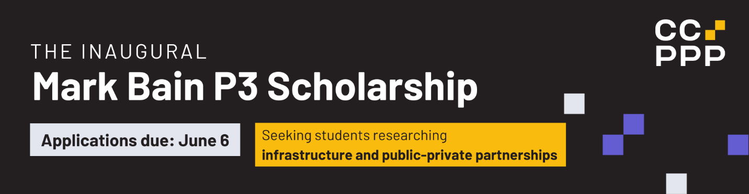

APPLICATION FORM
Please complete the following form and include as attachments:
- Completed form (including short bio)
- Resume
- Submitted paper. Your paper must have already been prepared and submitted as part of your coursework.
Submit your full application no later than 11:59 p.m. ET on Thursday, June 6, 2024, to partners@pppcouncil.ca. Incomplete applications will not be considered.

Name and contact information:

(Full name, postal address, telephone number and email are required)
**Please ensure this information will still be accurate as of September 2024)**

Name of post-secondary institution:
Field of study:
Expected graduation date:
Short Bio

